1. Login Visual Studio -> goto the project -> open Visual Studio
2. View -> Team Explore

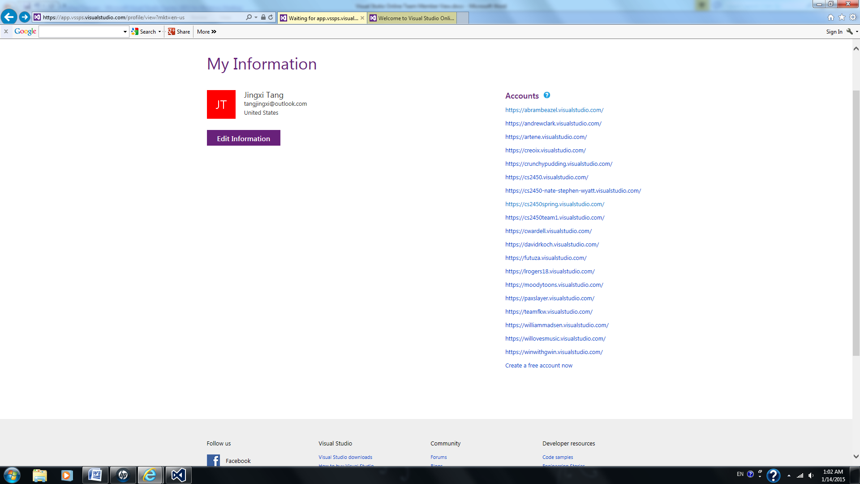

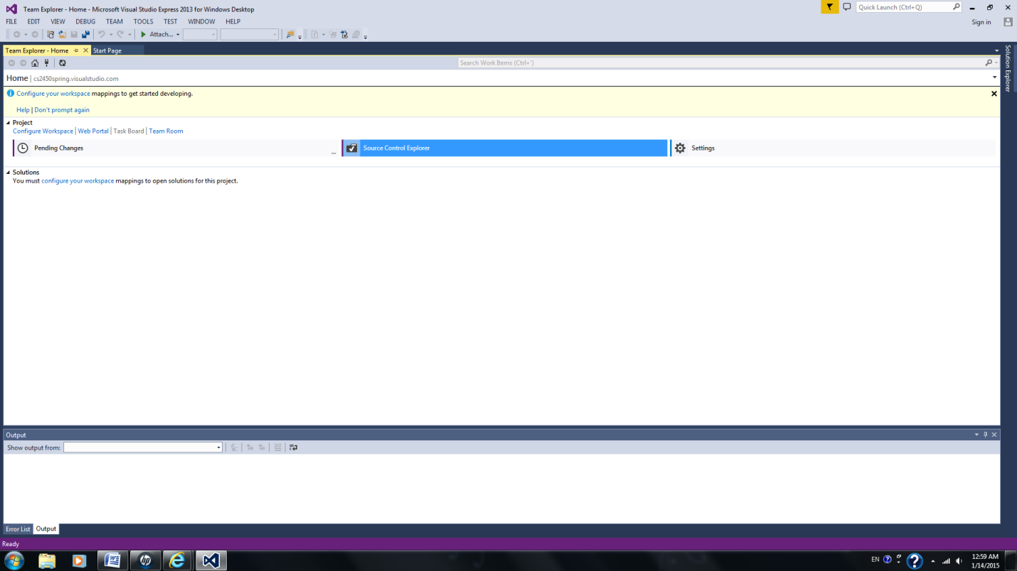

Connect to Team Project.

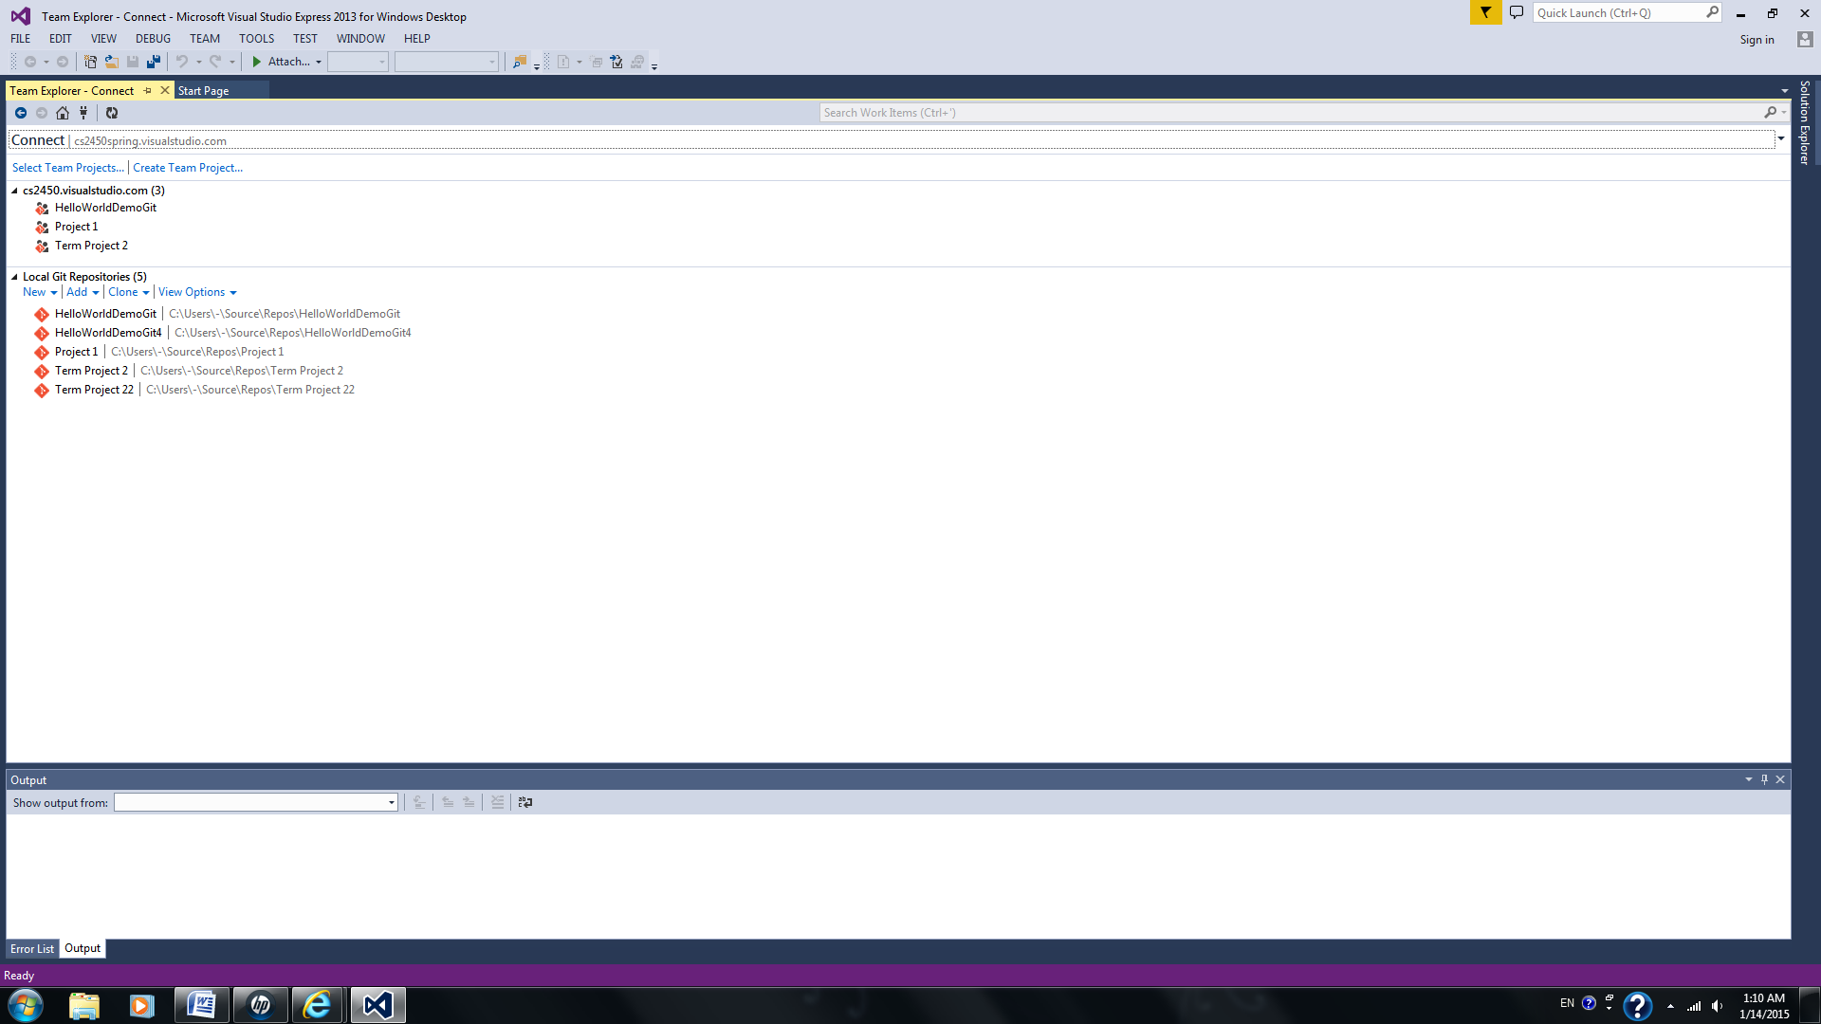

Select Team Project (select all)

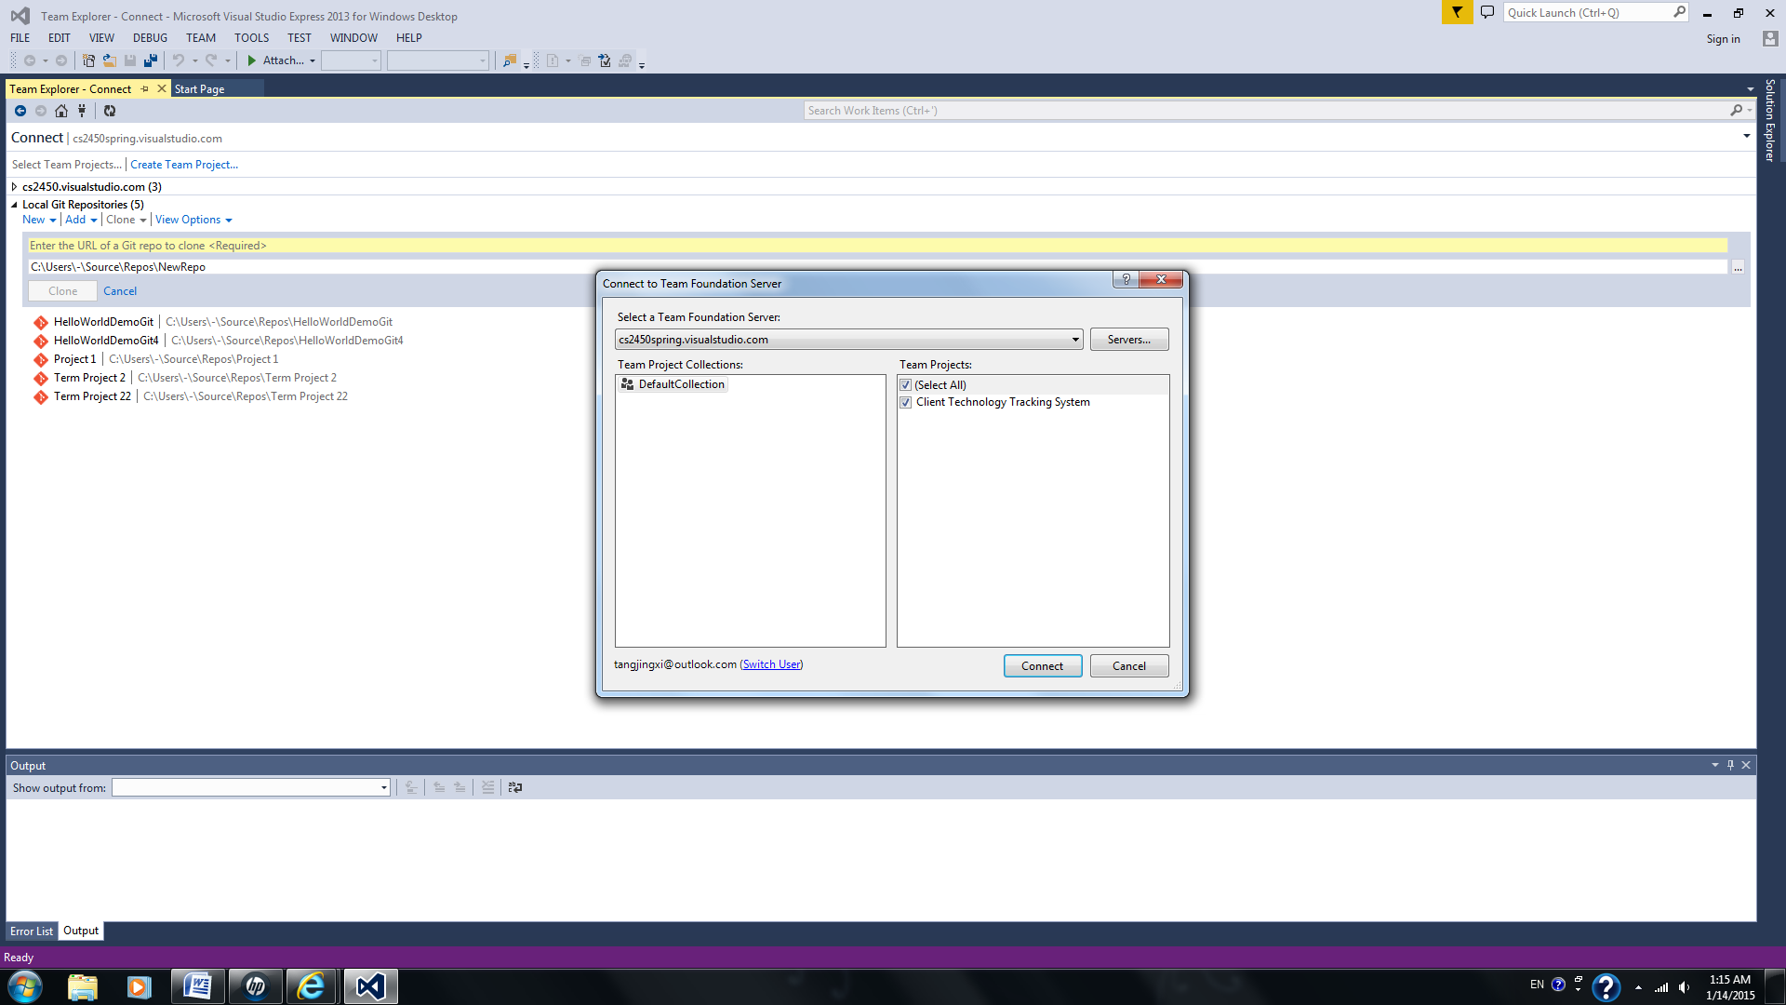

Highlight Client Technology Tracking System

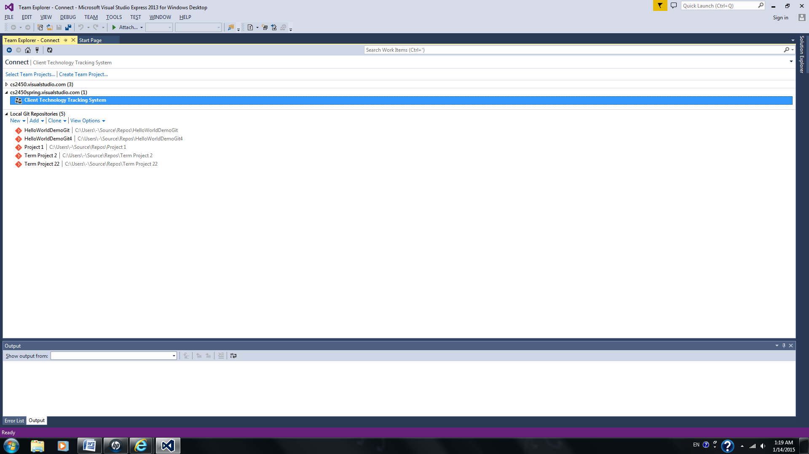

Right click -> connect

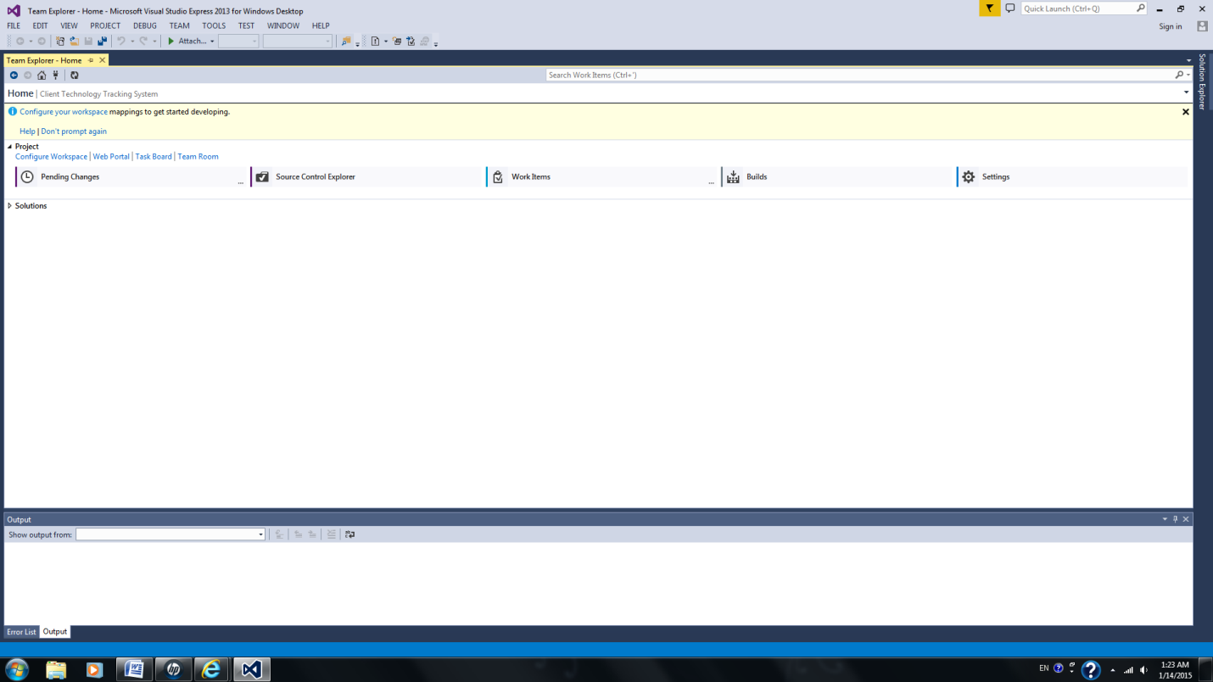

Source Control Explore

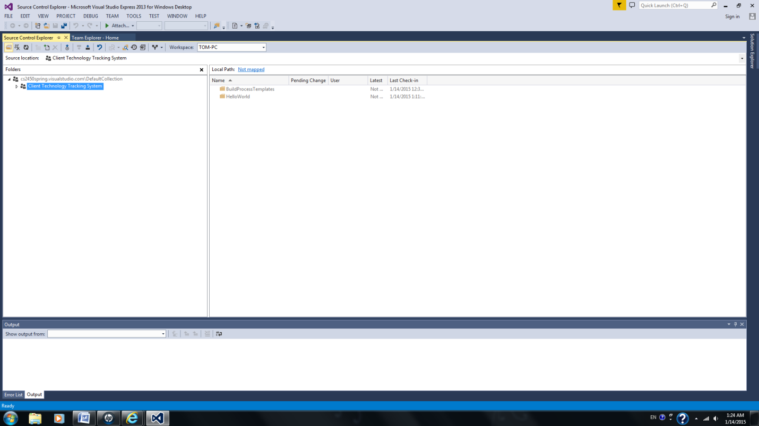

Open HelloWorld.cs (notice you cannot edit)

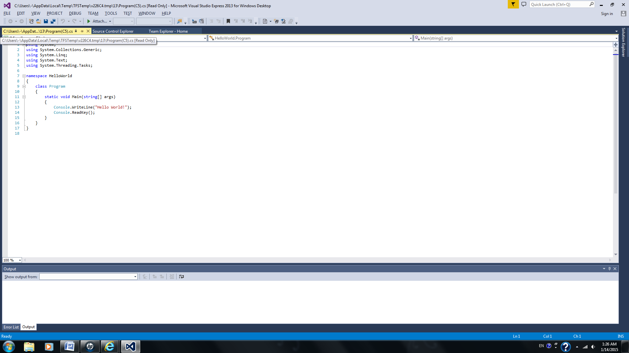

You have to configure Work Space

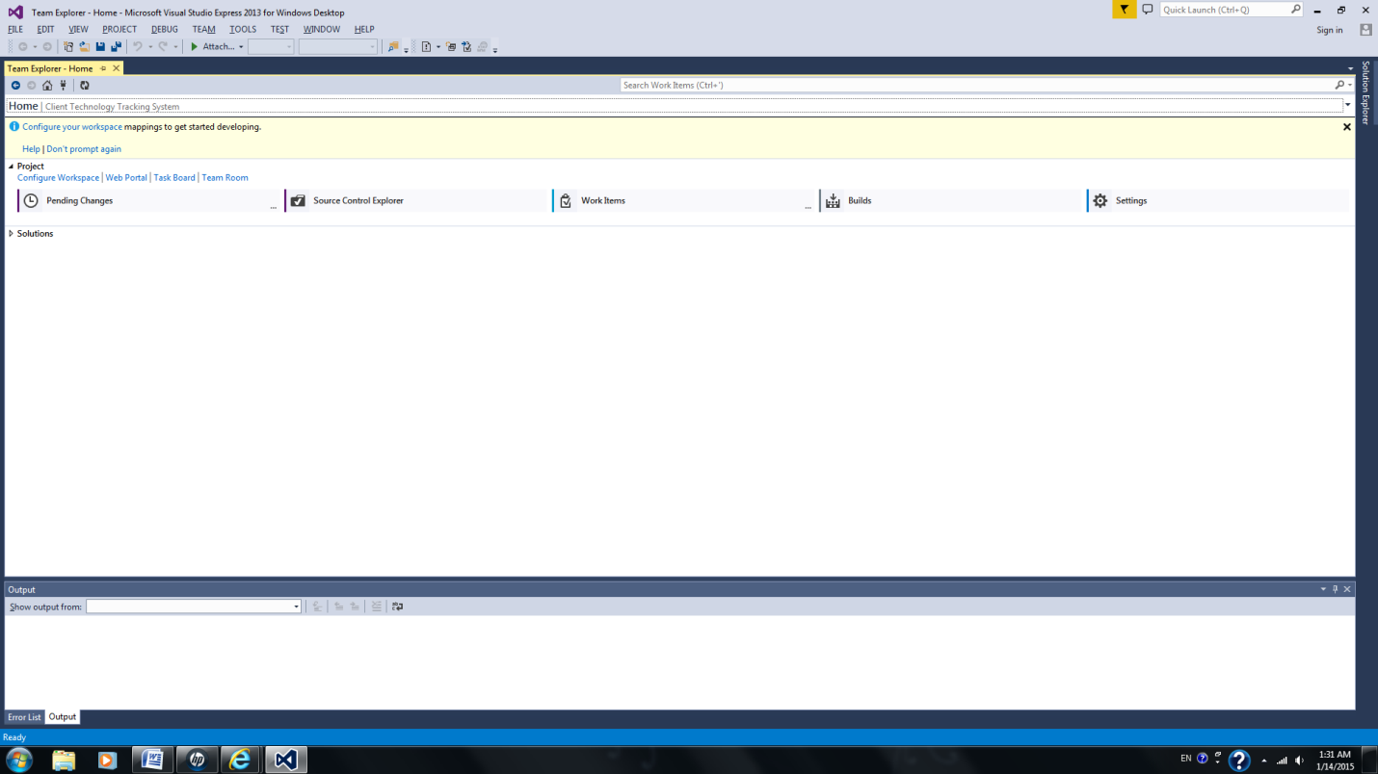

Map and Get (notice the local directory C:\Users\-\Source\Workspaces\Client Technology Tracking System)

Now you can edit (double click .sln if needed)

Notice the red check.

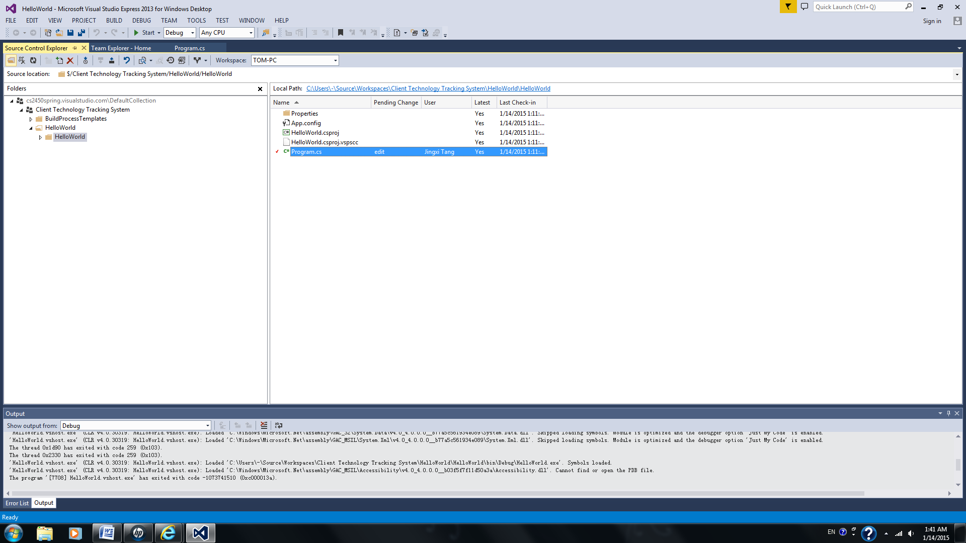

You can check in from the following places by right click.

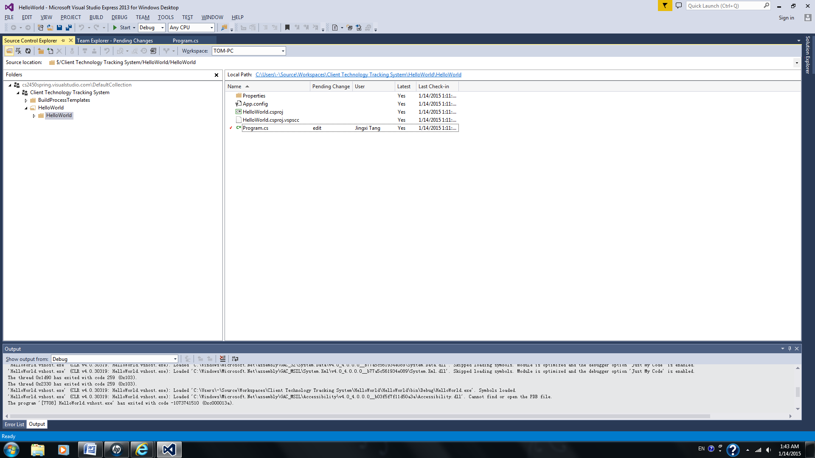

or

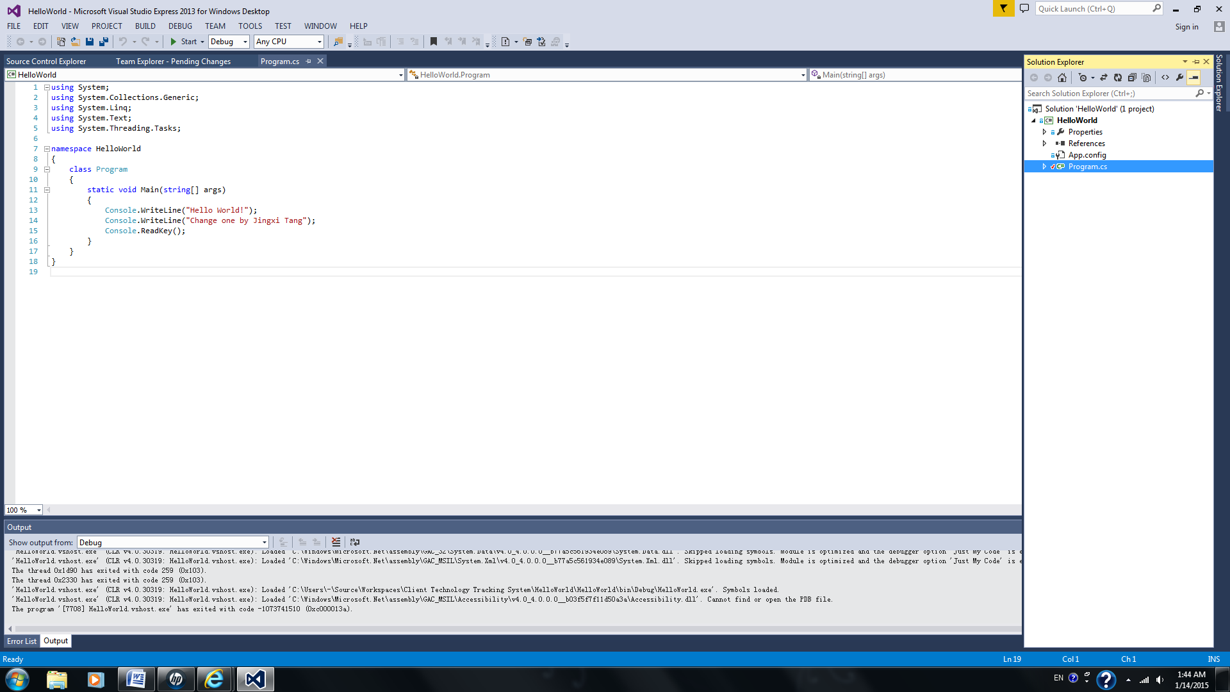

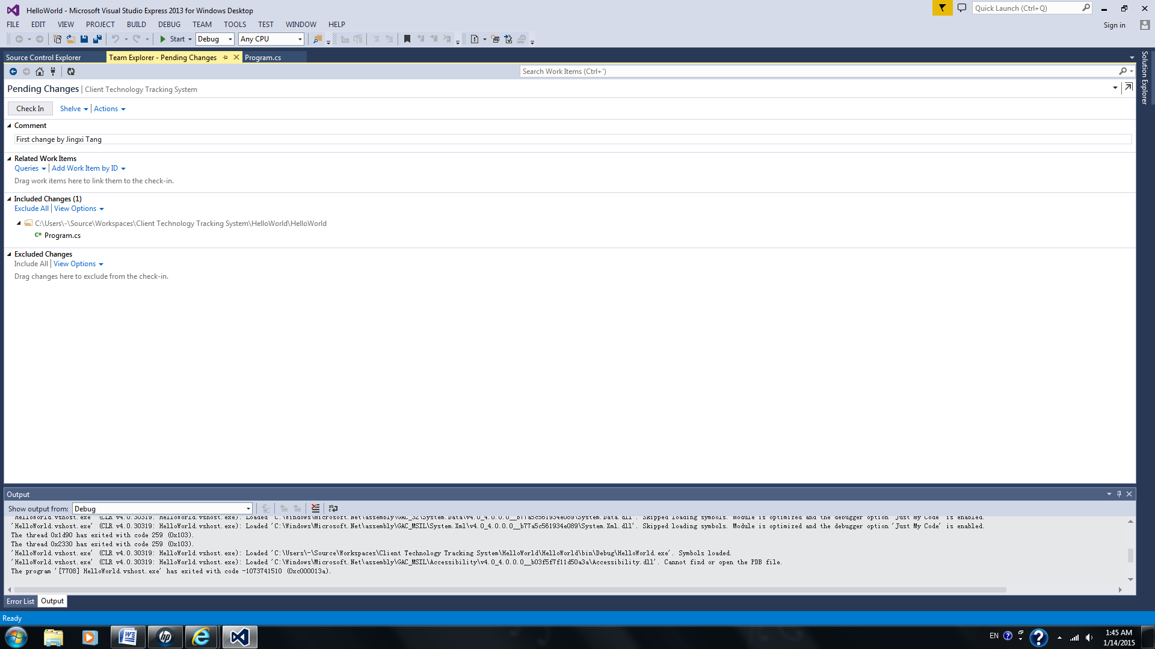

Right click on HelloWorld.cs -> Version Control ->view history ->right click -> Changeset Details/compare.